|  |  |
| --- | --- |
| Sony Cyber-shot DSC-RX100 Mark VII  Máy ảnh Sony Cyber-shot DSC-RX100 Mark VII | Chính hãng  Sony Alpha RX100 mark 7  Chính hãng (8) Sony Alpha RX100 mark 7  Chính hãng (10) Sony Alpha RX100 mark 7  Chính hãng (7) Sony Alpha RX100 mark 7  Chính hãng (11) | **Featured information:**  Sensor: 1 inch  ISO range: 100 - 12800 (expanded: 64 - 25600)  Resolution: 20.1MP  Wireless connection: WiFi, Bluetooth  Price : $ 1150  **Specifications:**  Sensor Format  N/A  Resolution  20.1 Megapixels  Size photo  5472 x 3648  Image Proportions  1:1, 3:2, 4:3, 16:9  Sensor Type  CMOS  Image Format  JPEG, Raw  Anti-Vibration  Digital, Optical  Lens Mount  N/A |

**Overview:**

As a compact camera, the Sony RX 100 Mark VII has a relatively compact design. The camera weighs about 302g, which is a relatively small number for a fully integrated camera like the Sony RX 100 Mark VII. The camera is equipped with a 3-inch touch screen with 921,600 pixels that allows users to operate easily. The screen design is suitable for taking photos/videos at many different angles.

The OLED electronic viewfinder has a resolution of 2.36 million pixels and 0.59x magnification to help create clear, sharp images. The viewfinder also uses ZEISS T* coating ensuring corner-to-corner clarity and is accessible with a single press for more convenient switching between LCD and EVF.

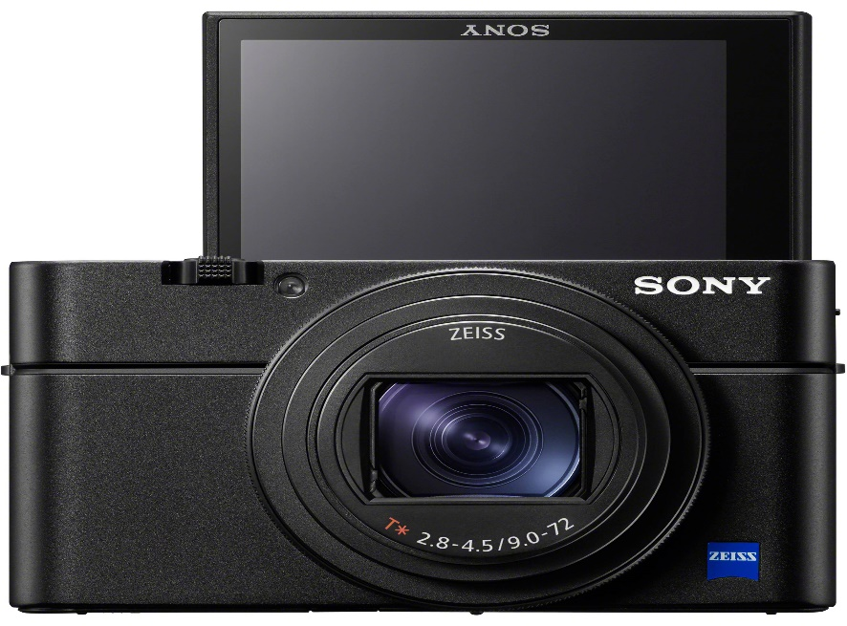

The Sony RX 100 Mark VII uses an advanced stacked structure with an integrated DRAM chip and an updated 20.1MP 1-inch Exmor RS CMOS sensor on the camera that can deliver superior image quality. Sensitivity from ISO 100-12800 can be expanded from 64 - 25600 for extremely fast focusing performance.

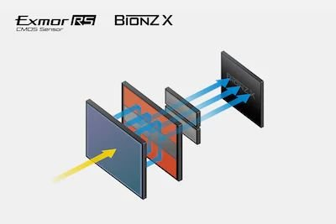

This sensor also has 357 phase-detection autofocus points and 425 contrast-detection areas for faster and more accurate focusing. The sensor combined with the BIONZ second.

Spanning focal lengths from 24-200mm, the ZEISS Vario-Sonnar T* lens is suitable for photography in a variety of situations. Wide-angle to mid-telephoto lens with flexible zoom range while still maintaining a compact form factor due to its maximum aperture range of f/2.8-4.5.

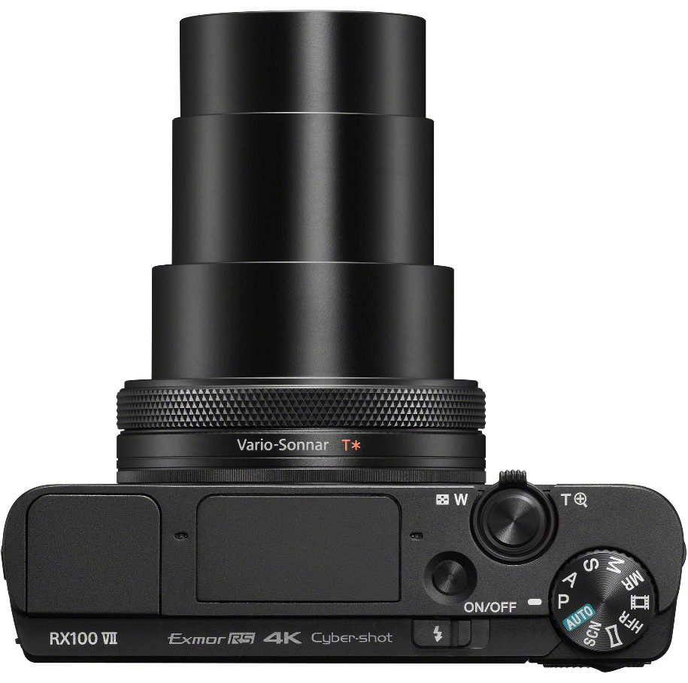

The lens's optical construction includes eight aspherical elements, including four advanced aspherical (AA) elements that greatly reduce aberrations and distortions to achieve high sharpness and accurate rendering. Additionally, the lens is coated with ZEISS T* anti-reflective coating to suppress reflections and glare for improved contrast and color fidelity.